

**P-1901 | FALL-22 | CS**

**Maid In**

**Abstract:**



In developing countries like Pakistan, the domestic service sector is at a severe disadvantage in comparison to many other service industries due to the minimal technological consideration and support given to expedite its functions, accessibility and processes for both customers who seek it and people who provide it and when further taking into account the dependence of a large chunk of the Pakistani populace on the profession for subsistence and survival, a strong digital solution should be implemented to minimize such issues and uplift the domestic service industry.

Our proposed solution is the introduction of an online mobile application platform similar in nature to services like bykea, careem etc. whose main purpose will be to allow better and quicker accommodations of domestic service requests from customers through widespread online advertisement to all registered and nearby service agents fit for performing the requested tasks which will simultaneously also allow for better awareness and accessibility for domestic service agents towards currently available service opportunities

Customers and service agents will be able to manage online transactions and negotiations, track and map each other’s locations and perform online financial transactions thus overthrowing the immemorial practices till existent in the domestic service industry

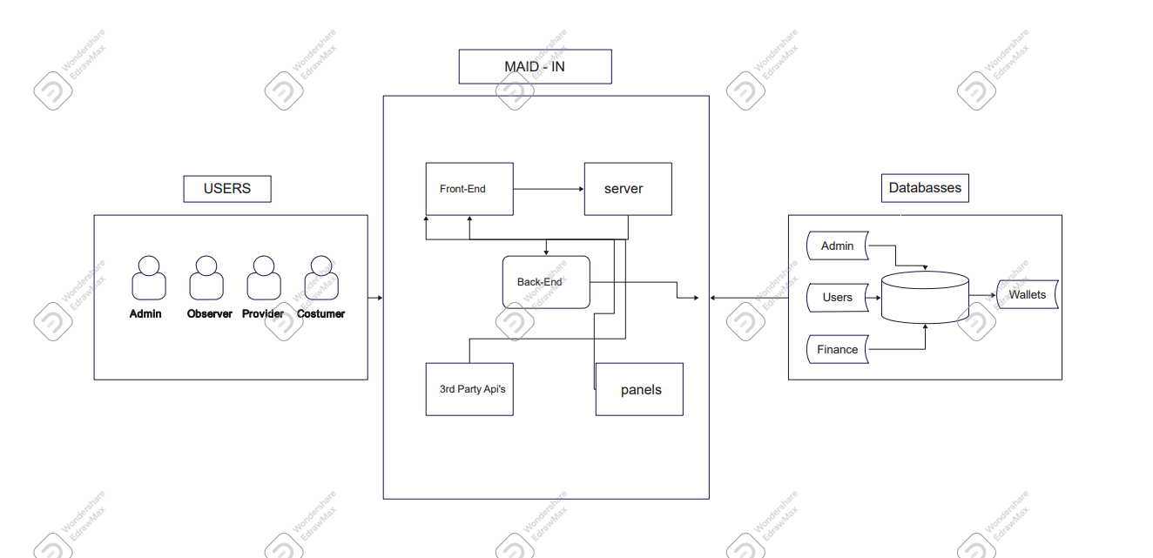

**Supervisors & Group Members:**

|  |  |  |
| --- | --- | --- |
| **S. No:** | **Name** | **Designation** |
| 1. | Arifa Mustafa | Supervisor |
| 2. | Huma Jamshed | Co-Supervisor |
| 3. | Inam Ullah | CS191086 |
| 4. | Faisal Zaman Haider | CS182013 |
| 5. | Poorab Gangwani | CS191092 |